TOP 15 SQL practice qns.
1.
/* 178. Rank Scores

+-------------+---------+
| Column Name | Type |
+-------------+---------+
| id | int |
| score | decimal |
+-------------+---------+
id is the primary key (column with unique values) for this table.
Each row of this table contains the score of a game. Score is a floating point value with two decimal places.

Write a solution to find the rank of the scores. The ranking should be calculated according to the following rules:

The scores should be ranked from the highest to the lowest.
If there is a tie between two scores, both should have the same ranking.
After a tie, the next ranking number should be the next consecutive integer value. In other words, there should be no holes between ranks.
Return the result table ordered by score in descending order.

The result format is in the following example.

Example 1:

Input:
Scores table:
+----+-------+
| id | score |
+----+-------+
| 1 | 3.50 |
| 2 | 3.65 |
| 3 | 4.00 |
| 4 | 3.85 |
| 5 | 4.00 |
| 6 | 3.65 |
+----+-------+
Output:
+-------+------+
| score | rank |
+-------+------+
| 4.00 | 1 |
| 4.00 | 1 |
| 3.85 | 2 |
| 3.65 | 3 |
| 3.65 | 3 |
| 3.50 | 4 |
+-------+------+ */

create database Rank_scores;

use Rank_scores;

drop table if exists scores;

create table scores (
id int primary key,
score decimal(5,2));

/* DECIMAL(precision, scale) --

Precision = 5

➡ Total number of digits allowed (both left & right of decimal)

🔹 Scale = 2

➡ Number of digits allowed after the decimal point

valid:
123.45
99.99

Invalid:
1234.56 -- 6 digits total ❌
10.999

*/

select * from scores;

insert into scores (id,score) values
(1, 3.50),
(2, 3.65),
(3, 4.00),
(4, 3.85),
(5, 4.00),
(6, 3.65);

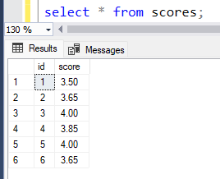

Windows function –
Window functions perform calculations across a set of rows related to the current row without reducing rows.
3 types ----
- Ranking windows function
Row_number() - Assigns a unique sequential number to each row, even if values are the same – 1,2,3,4,5 etc….
Rank() – same ties same rank, gaps – 1, 2,2, 4 ,5,5,5,8 etc…
Dense_Rank() – same ties same rank, no gaps—1,1,2,3,3,4 etc …
Ntile(n) – based on n value – the table is grouped and value is given
• SQL tries to distribute rows as evenly as possible
• Extra rows go to earlier buckets

Eg: if n=4 – total rows is 10 – 3,2,3,2 rows grouped –can group anything
So for 1st 3 values rank 1, next 2 rank 2, next 3 rank 3, next 2 rank 4

- Aggregate windows function
Min(), Max(), Sum(), Avg(), Count()

- Value (Offset windows function)
Lag() – previous row value
Lead() – next row value
First_value() – first row value
Last_value() – last row value

For windows function we should use over()

- Diff b/w group by and windows function

Group by – reduces rows and gives only one value in answer
Windows function – keeps all rows—without confuse gives answer in all rows based on condition

Over(partition by column name)
Over(partition by column name order by column name asc/desc)

WINDOW FUNCTIONS
Window functions perform calculations across a set of rows related to the current row without reducing rows.

🔸 Types of Window Functions

1️⃣ Ranking Window Functions
ROW_NUMBER()
RANK()
DENSE_RANK()
NTILE(n)
- ROW_NUMBER()
  - Unique sequential number
  - No ties
  - Example: 1,2,3,4
- RANK()
  - Same values → same rank
  - Gaps appear
  - Example: 1,2,2,4
- DENSE_RANK()
  - Same values → same rank
  - No gaps
  - Example: 1,1,2,3
- NTILE(n)
  - Divides rows into n groups
  - Rows distributed as evenly as possible
  - Extra rows go to earlier groups

2️⃣ Aggregate Window Functions
MIN(), MAX(), SUM(), AVG(), COUNT()
- Used with OVER()
- Keeps all rows
- Example:
AVG(salary) OVER (PARTITION BY department)

3️⃣ Value / Offset Window Functions
LAG() -- previous row value
LEAD() -- next row value
FIRST_VALUE()
LAST_VALUE()
Used for:
- Comparing current row with previous/next row
- Trend analysis

🔹 OVER() Clause (MANDATORY)
OVER (
PARTITION BY column_name
ORDER BY column_name ASC | DESC
)
- PARTITION BY → divides data into groups
- ORDER BY → defines row sequence

🔹 GROUP BY vs WINDOW FUNCTIONS
GROUP BY | WINDOW FUNCTION
Reduces rows | Keeps all rows
Summary output | Analytical output
One row per group | Result on every row

🧠 Interview Power Lines (Use these)
“Window functions allow analytical calculations without collapsing the result set.”
“PARTITION BY groups rows logically, unlike GROUP BY which aggregates rows.”
“DENSE_RANK is preferred when ranking with ties without gaps.”

select score, dense_rank() over(order by score desc) as rank from scores;

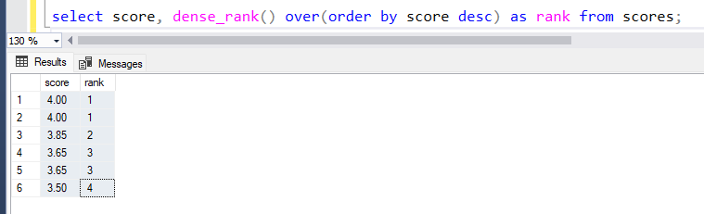

DENSE_RANK() cannot work alone.
All ranking functions must be used with OVER().

